Question
- What is self-leaderships, discuss both three self-leaderships strategy and how they operated (behavior- focus strategy, thought-focused strategies and emotion-focus strategy)

- What is self-leadership?

Genera definition
- It is staking responsibility for your own performance and wellbeing, not relying on other and self-initiatively take positive approach in your own work and personal life
Literature definition
- Comprehensive self-influence perspective that concerns leading oneself towards preference of naturally motivating task as well as managing one-self to do work that must be done but is not naturally motivated. (Manz, 1986)
- A form of motivational process that can influence personal effectiveness

This part is just for the understanding of the topic
Background-why there is self-leaderships

in the past, academic field had focused on how organization control system can act as an external force to identify desirable behavior, monitor employee’s behavior and coordinate, reward or punish according to employee’s behavior; and culture to provide belief and value for future to improve performance. However, alternative view suggest that each individual can be seen as a processing control system. Organization provided standard, evaluation and reward-punish system, individual can also provide for themselves. Organization control system does not directly access individual employees.

Manz (1986) pointed out that organization control system act as a bigger framework for self-control system. Social cognitive theory suggests that environment and human behavior influence and interact with each other. Organization provided control system that are determined (intended and unintendedly) by the self-control systems of each human in the organization. Standard emerge from hierarchical organization control system. Cybernetic self-regulation system shows that : The employee work to best achieve (not deviated from their standard) their value, belief, script and program at one level (like produce the right quantity in time), which serve to higher level abstraction system and higher-level abstraction standard (job responsibility).
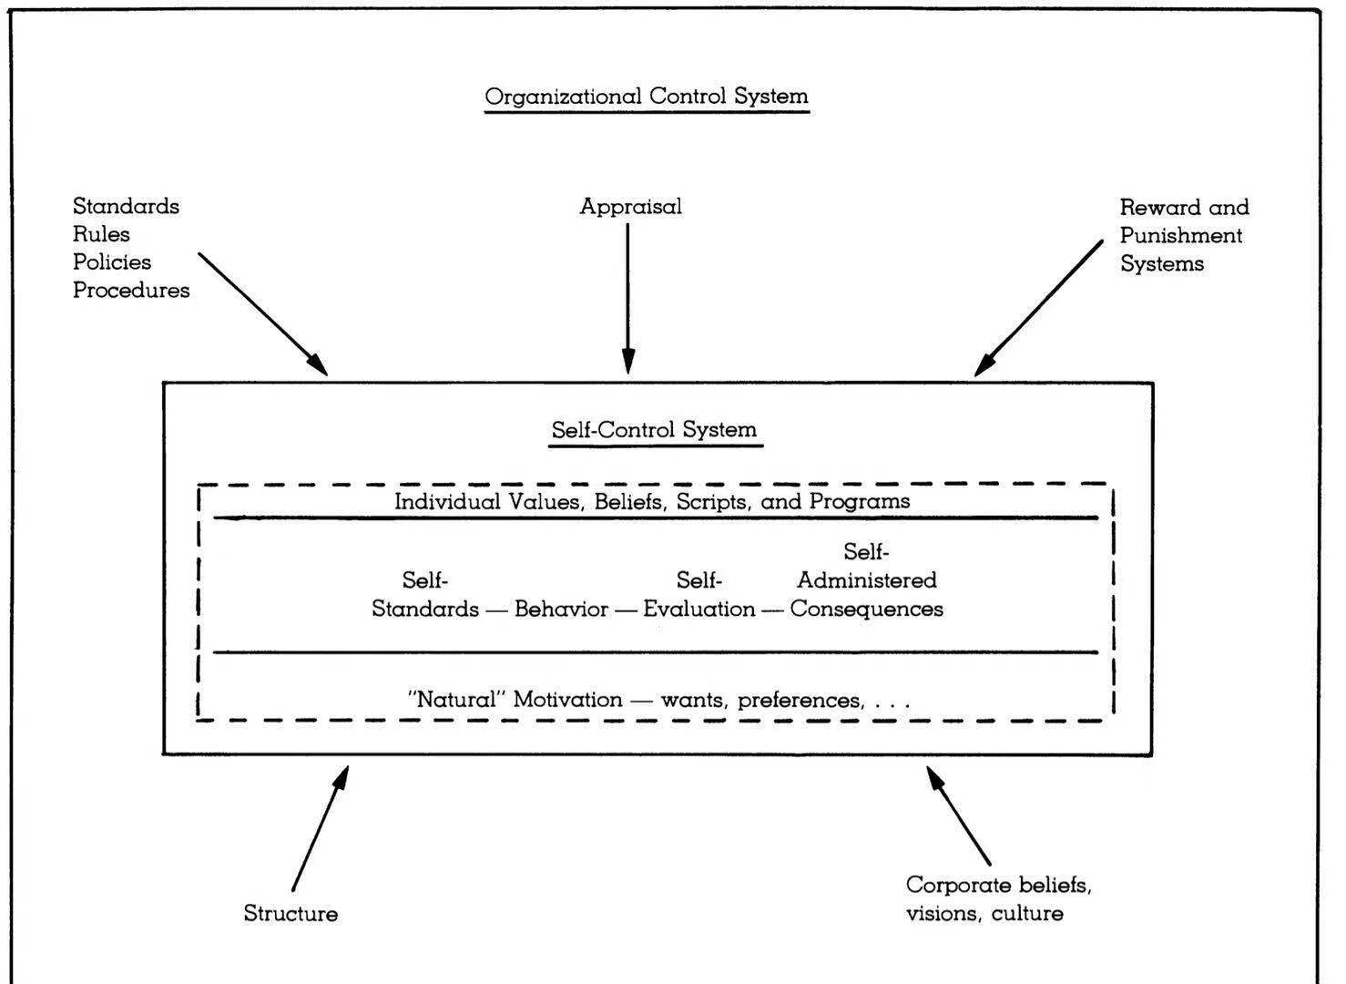Also, overreliances on external control by organization will led to bad behavior: rigid bureaucratic, only doing those that are rewarded but not necessary ‘right/beneficial/ethical’ to the organization.

Theory background
- Originated from social learning theory, self-determination theory and social cognitive theory, self-leadership was introduced by Manz in 1986.
Social cognitive theory
How environment dimensions (social context) interact to influence each other and human behavior (人的行为和身边的环境会互相影响)
Self-regulation theory (Social learning theory)
Suggested that people will actively use strategies in these dimensions to set goals and standards, and then regulate motivation and performance to accomplish the set goals
Self-leadership is based on the assumption that employee/people will set goal/standards that excessed organizational standards and expectation; and people with high self-leaderships believe themselves are able to achieve it

Self-leaderships facilitate desirable goals that consistence with the value and goals

- Self-leadership strategies

- Behavioral focused strategies
Behavioral-focused strategies encourage individual to generate desirable behavior that will lead to positive outcome and at the same time reduce undesirable behavior. This strategy involved several sub-strategies: (Neck & Houghton 2006)

- Self-observing involved observation of behaviors under different situations, evaluate what is desirable and undesirable behavior, which they should or should not continue. Allow employee to self-monitor and self-aware their own behavior and performance.
e.g.: you observed yourself were nervous and procrastinate under time pressure, you evaluate that this behavior led to bad work performance and you been punished by reduce bonus; then you have decided not to continue procrastinated behavior.

- Self-goal setting, as said in locked & Latham’s goal setting theory, is a tool to improve performance by motivate employee to input effort to achieve goals. Goal setting theory in motivation suggest goals should be achievable and challengeable, SMART goals. In relations to self-efficiency theory, people who has high self-leadership will believe themselves and put greater efforts in to achieve the goal. Goals commitment also suggest open, known, self-set goals that consistence with the organizational goals will facilitate individual commitment to the goals. Therefore, this strategy enhance motivation.
you set goals that you are going to finish your work 2-3 days ahead of the deadline according to the amount of work need to be done.

- Self-reward
- The important of goal setting process; using significant objects, thought or events to strengthen motivation to achieve the goals (goal setting theory)

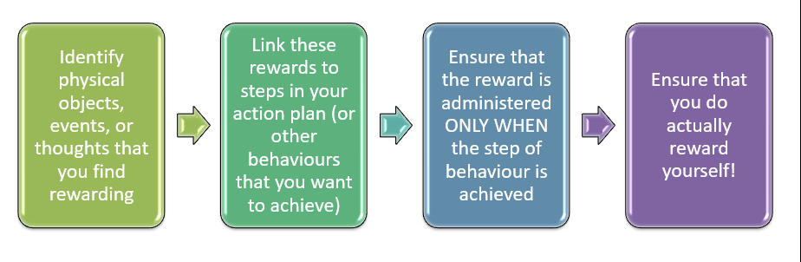
e.g.: your find enjoyable when spend time with your friend, you set the reward for not achieve the goals of done work 2-3 days ahead the deadline, you called your friend once you have achieved the goals and enjoy time with them. Events example
4. Self-cueing
Use cues- to increase desirable behavior
- Reminder an attention focuser
- Use physical object to reminder yourself what to do
(e.g.: to do list, calendar and sign)
- Increase positive cues
- Surrounding yourself with people or object that encourage desirable behavior that can actually increase those behavior
(e.g.: spend time with people who can motivate you, or have picture or music that help you concentrate)
and decrease undesirable behavior
remove the cues that support undesirable behavior
(e.g.: delete shortcut, reduce phone using time)

- To practice the actives before performance (identify problem, action and future prediction before the actual events)

- Emotional-focused strategy / natural reward

This strategy is based on the extrinsic and intrinsic motivation in self-determinant. (define intrinsic and extrinsic motivation and give example) self-determine theory suggested that individual have different type of motivation based on different goals/reasons. It suggests three basics psychological (intrinsic) need for self-efficacy: competence, relatedness and autonomy. People tended to continue the action they find pleasure and stop when they find it struggle or did not fulfil the psychological needs. Natural reward focus on building more enjoyable feature into a given activity, so that the task or job itself become naturally rewarded. It included a commitment to, believe in and enjoyment of the value for this work. Therefore, Natural reward strategy is specifically useful when employee is trying to tackle with unpleasant situation of the work task itself.

In order to make the work more natural rewarded, redesign, refocus and reframe strategies can facilitate self-leaderships. Before that, individual has to discover and analysis what element in work make work itself enjoyable. Asked ourselves how the work is entailed, where the job is entailed and how dose the job element related to your other goals.(this require self-awareness) Give example in here.

- Positively redesign the job can be done by two ways: to change how and where the job is carried out. This strategy was principled by job-design theory. How? According to Job Characteristic Model (JCM) five core job dimensions: skills variety, task identity, task significant, autonomy and Feedback have effect on the three intrinsic state of work and led to desirable work performance and satisfaction. The process to redesign the job by job enlargement (job extension and job rotation), job enrichment (to increase the degree of control/autonomy if it is natural rewarded to yourself), and goal setting etc. Where? The environment your work that make you feel rewarded and more enjoyable to carry the task. For example, studying in the library, working from home (telecommunicate, virtual office) Self Job-redesign allow individual to find meaning in their everyday work/tasks.
However, In the workplace, job redesigned is not up to individual to initiate, normally is manager or HR.
- Employee themselves are less likely to redesign their job when they are unsatisfied. Therefore, individual can also reframe and refocus the existing work/tasks context. It is aim to change how people think about this job. A work or task might involve both desirable and undesirable task. Refocusing is the strategy that suggest individual to focus on the positive pert of the task. For example, when a task require you to gain knowledge of a completely new area, even though it takes times and effort, but think it as a process of gaining new knowledge can led to more positive attitude towards the task. Reframing is to increase the level of meaning that associated with your current work. For example, when work as a intern and doing work struggle, thinking it as a long-term goods that it is the necessary stage for you progress in your future career.

Thought-focused strategy
Thought focused strategy are used to alter though in desirable way that can positively impact the performance. Many dysfunctional thought patterns might involve in our life and work. Therefore it is encouraged for organization or employee themselves to think positively.

The aim of this strategy is to identify the negative thought and change it to positive, using improved scripts and self-take. To improve one’s thought, we need to identify beliefs, value and assumption, which might positively impact on or form one’s thought. Then is to identify the dysfunctional thought pattern in one’s daily thought.
List of dysfunctional though pattern: (Burn 1980)

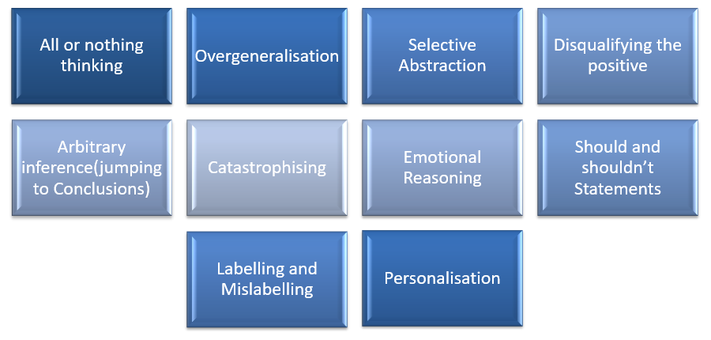

To challenge the thought and replace the negative with positive. Improve script are one of the useful strategies to counter dysfunctional thought. Manz suggest that individual should replace dysfunction thought to functional though by more rational thinking. Mental script is individual perception of an events based from previous experience in life. For example, if you found yourself to be a ALL OR NOTHING person, that means that you always have the thought of never, totally and perfectly etc, your world is either white or black. In this case, try to see things that you use to said not with as a challenge and gradually try to adapt it and try it, analysis the possibility of your ability to do this work rather than fear and never do it.

Imagination can also be a useful strategy, mental practice can be used visualize one’s performance before the actual events. This strategy have been found to influence one’s positive thinking and improve performance at field of sport psychology, clinical psychology etc. This strategy help individual to visualise desirable goals, and associate the task with success which will encourage positive performance. For example, if you think run for 4 km in 30 mins every day is too hard, try to imagen when you continue this exercise for days and you see yourself in the mirror more in shape and fit.

Self-talk is the inner speech to yourself. Constructive self-talk act as a reinforcement to positive thought and motivation, which help to boots confidence of finalizing the task. The research has also found self-talk increase cognitive procession that led to improved in problem solving. For example, when you need to do a presentation that you are not confident with and you want to quit, before you go up the stage, try to keep telling yourself that it is going to be fine.

